Library Report
For Oct. 2018

Patron Counts

Patron 407
Internet 130
WIFI 20
Circulation 255

Students 112 Visits 112

Health & Community Services Fair
The Fair at the Dilley Convention Center on Oct. 10, 2018 was a Great success! The vendors that participated were: Cluster XII, Medina Electric; Dilley ISD; AACOG, Texas A&M AgriLife Ext, Amerigroup, Physicians Mutual, Endeavors, Phoenix Silica, Lit Pups Daycare Center, Texas Workforce Solutions, Cotulla Chamber of Commerce, ART, UTHSCSA, Brown Hearing Center, Cotulla STRHS and Trifecta. We had 75 or more attending the fair w/staff, vendors, guests and volunteers. We want to thank these organizations for their support on this very awesome event. Thank you to Council Members Gilbert Equia and Sabino Mena for attending the fair and their assistance and to David Jordan, Interim City Administrator and Council Members for all their support. Gratitude to the city employees that in one way or the other helped the Library Director in this event; Juanita Fonseca, Noe Garcia, Saul Fonseca, Arnold Zepeda, Junior Martinez, Becky Guajardo, Omar Hernandez and Jimmy Oranday. We want to thank all of the organizations that donated door prizes.

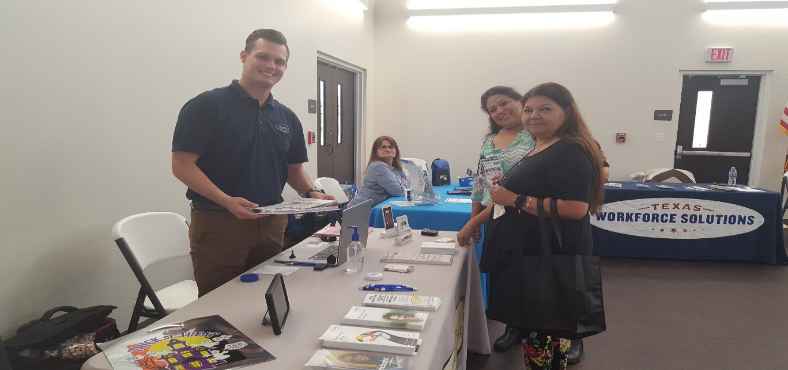
Brown Hearing Center

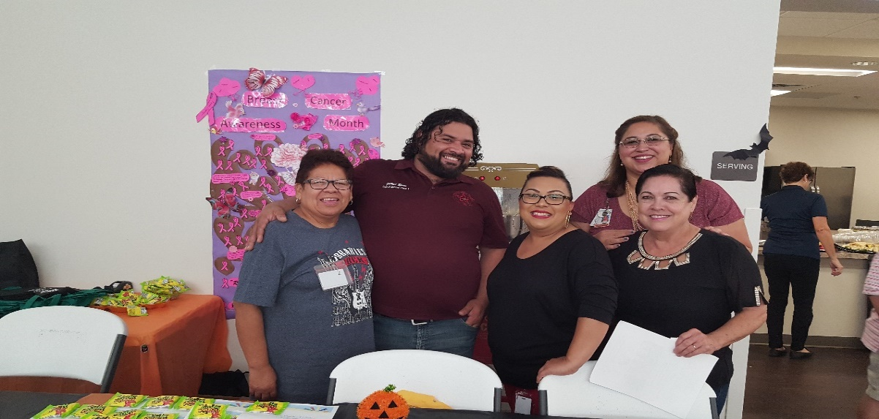
Dilley Public Library
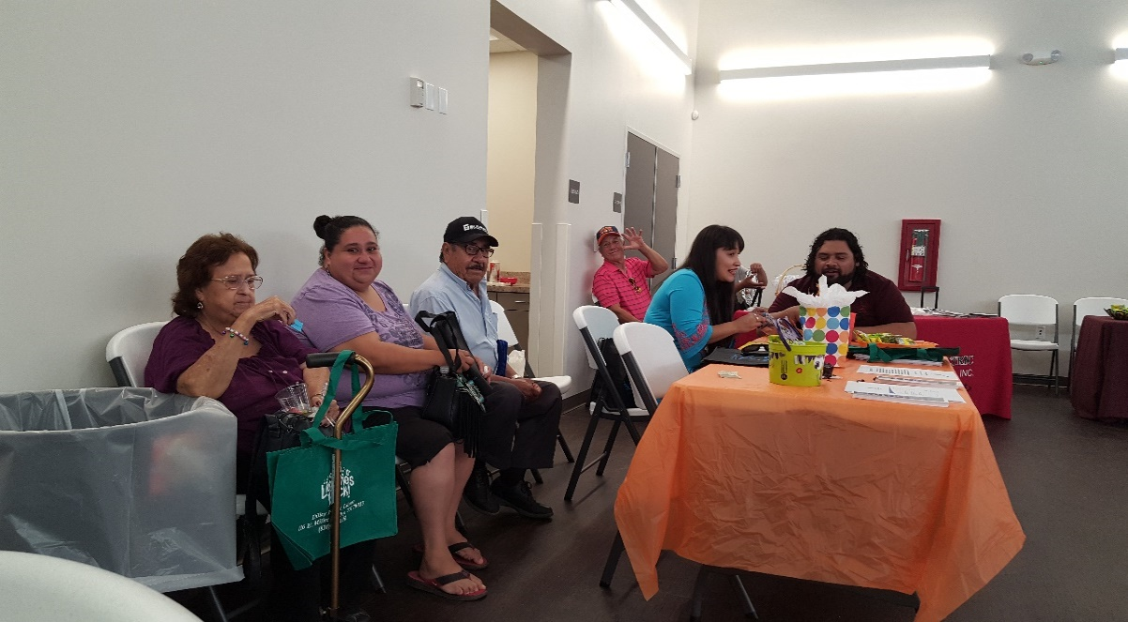

Visitors enjoyed the food, drinks, sweets and treats from all of the companies. Some waited for appointments and meetings w/Brown Hearing, AACOG and applications were passed out by Lil Pup’s for free child care services for parents that worked and/or qualified.

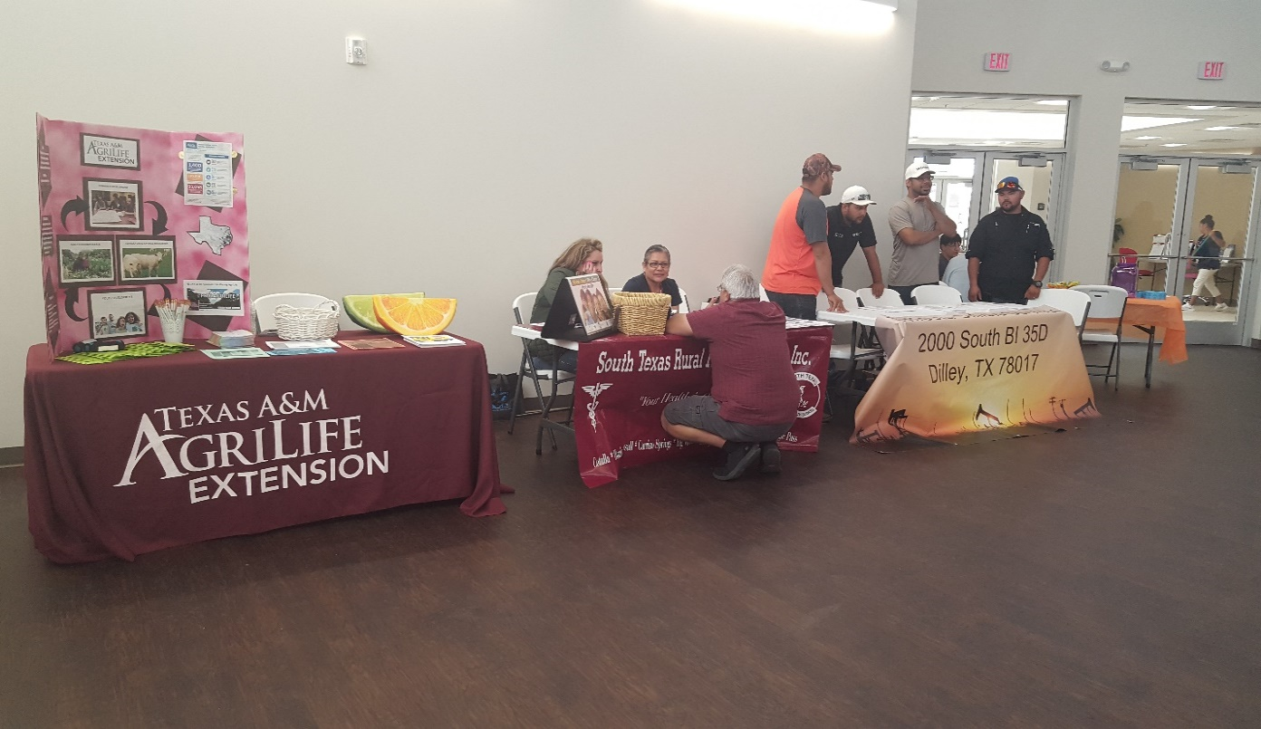

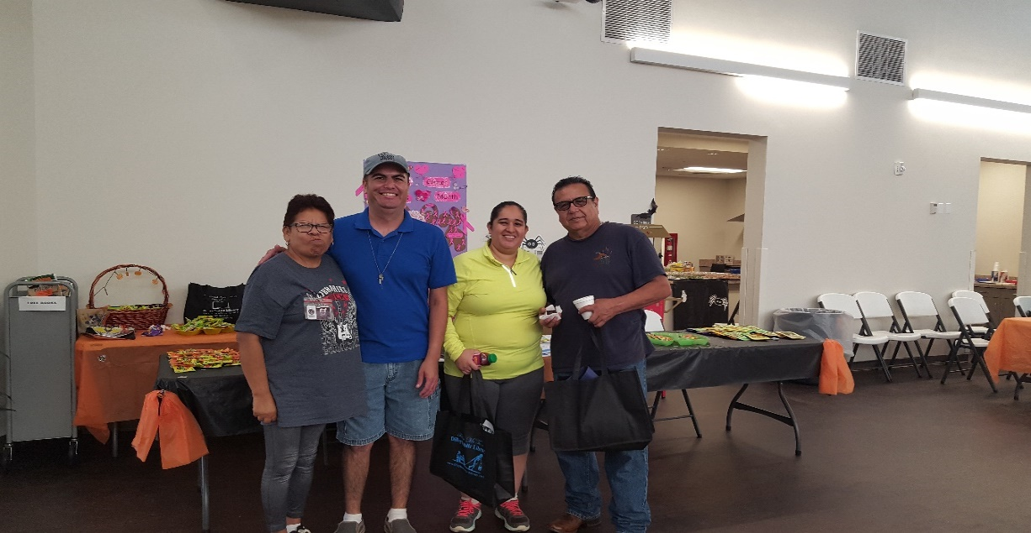

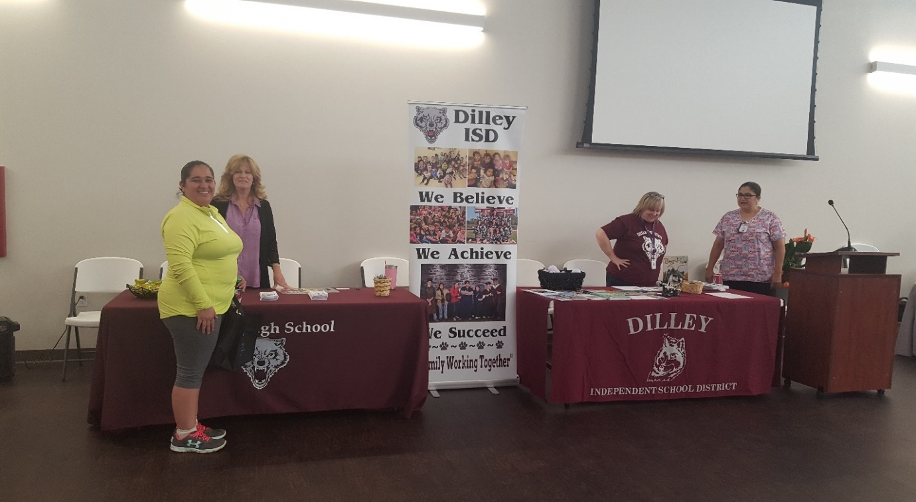
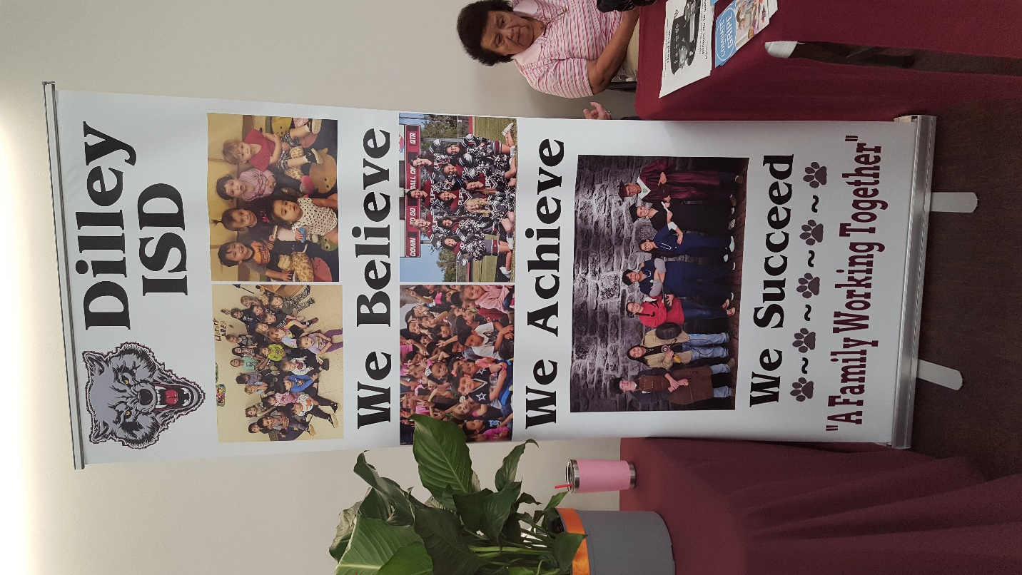
With the DISD we had Brenda Gandara, School nurse Melody Carroll, Administrative Facilitator and Carla Wimberley, Cluster XII visiting.
Health & Community Services Fair Vendors
Name Agency Email

Carla Wimberley Cluster XII carla_wimberley@pearsallisd.org
Katie K. Haby Medina EC katieh@medinaec.org
mycoop@medinaec.org
Melody Carroll DilleyISD melody.carroll@dilleyisd.net
Elia Pardo AAA epardo@aacog.com
Jocelin Villarreal Agrilife Ext. jocelin.villarreal@ag.tamu.edu
Linda Berlanga Amerigroup linda.berlangs@amerigroup.com

AC Montemayor/ Physicians Mutual/ augustinmontemayor@hotmail.com
Pamela Morganroth Pyhsicians Mutual pmorhgan@satx.com

Juliana Burns Endeavors jbarnes@endevors.org

Teresa Estrada Endeavors testrada@endevors.org

Gilbert Eguia Phoenix Silcia geguia@cityofdilleytx.com

Richard San Miguel Lil Pups Day Care littlepupsdaycare@gmail.com
Velma Benavidez Lil Pups Day Care velma64@yahoo.com
Sylvia A. San Miguel Lil Pups Day Care sylviarichard@yahoo.com

Vanessa Garcia Texas Workforce Solutions venessa.garcia@twc.state.tx.us
Laura Trevnio Texas Workforce Solutions laura.trevino@twc.state.tx.us

Matthew Toohey/ Brown Hearing Centers/ mtoohey@brownhearingcenters.com

Irene Soto Cotulla STRHS cac.strhs@tachc.org

Eric Parham /Trifecta /830-302-6897/2000 South BL 35 D, Dilley, Tx.

Robotics Fun for Home Schoolers at the Dilley Public Library

On Oct. 16, 2018, Home Schoolers from the community visited the Dilley Public Library for a very energetic and enthusiastic visit. The students were first given an explanation of how to use the library and they each applied for a Library Card. They were then given a tour of the library and to show them how the books were arranged by category using the Dewey Decimal System. After the children browsed the book shelves they each logged on to the library’s catalog to explore all the books available to them. They learned how to search for a title online and where to find them in the library. Our next lesson will be to teach the children how to log on to the Lone Star Digital EBooks. The second half of their visit to library was to build a Robot with the library’s Robotic Kits. The children were having so much fun w/the Robotic Kits that another trip was scheduled to finish and work on more movable Robots. Alone with the computerized activity the children will have a Scavenger Hunt:
- Find a chapter book with an author whose last name begins with “C”. What is the title of the book?
- Find an Easy/Reader book on your grade level. Who is the author?
- What is the call number for dictionaries?
- Does the Children’s area have music CDs? Can you find a CD you would like to check out?
- What do the numbers mean on the spines of nonfiction books?
6. What is the title of your favorite book? Who is the author?

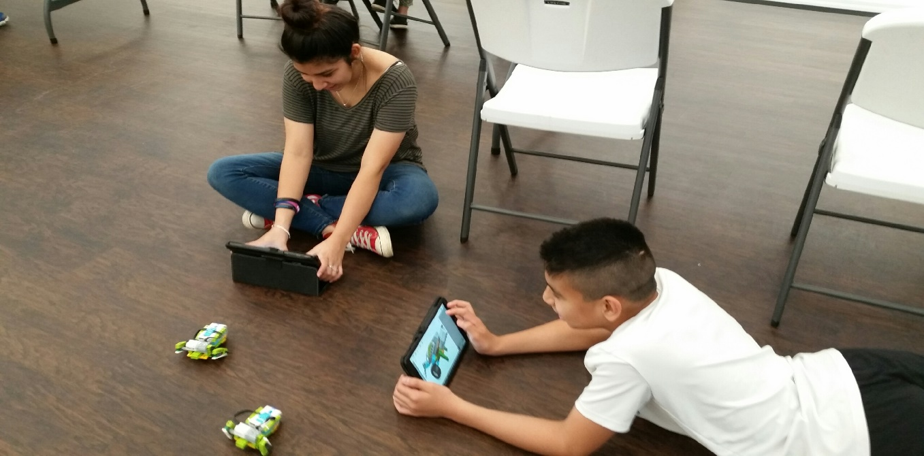
They Move…

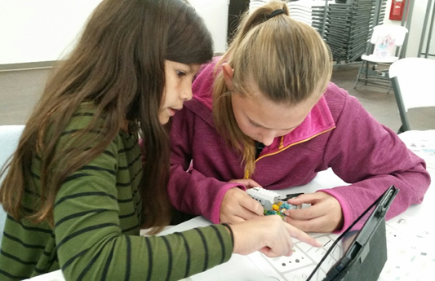
We have to get it just right for it to work!

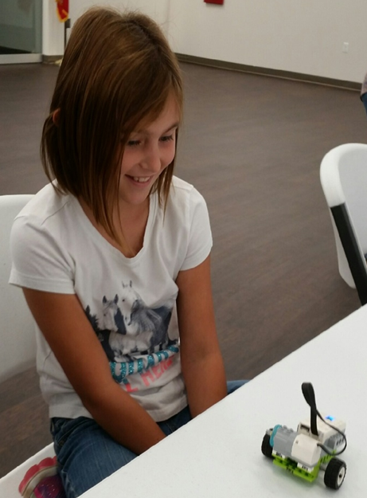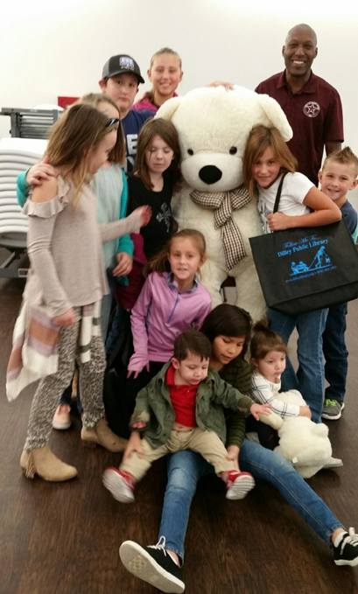
I did it!
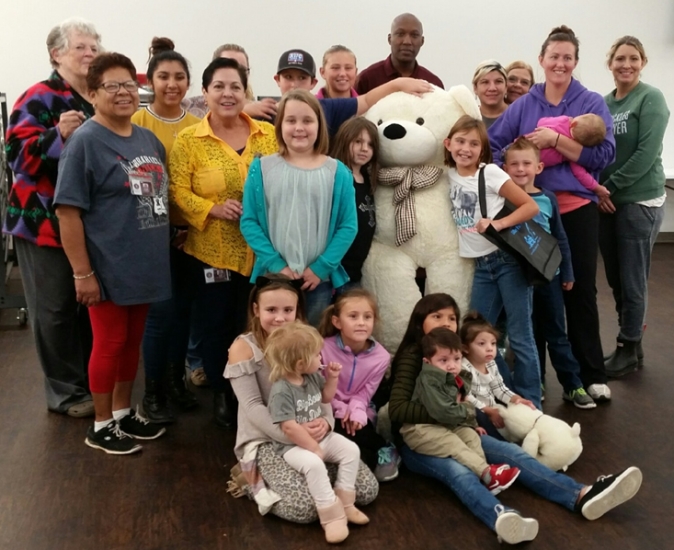

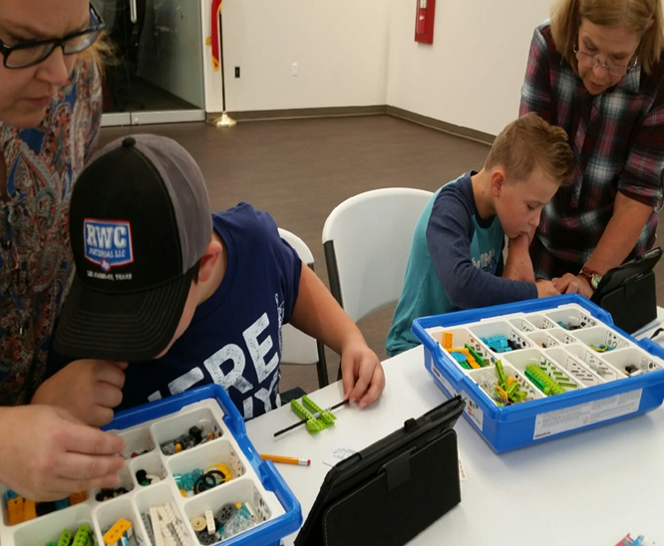
Is that the right LEGO piece?

Story Hour
We had Story Hour on Oct. 19, 2018 at 9:30 AM. It went great! Our Reader was Christian Obregon we really appreciate him reading to the children. Christian read “Can’t Sleep Little Bear” to the children; they were asked questions on the story and given stickers. An activity book was given to each child to take home to share with their parents. The children had snacks compliments of the City of Dilley. Thank you to Council Member Gilbert Equia and Interim Administrator David Jordan for visiting with the children and the staff.

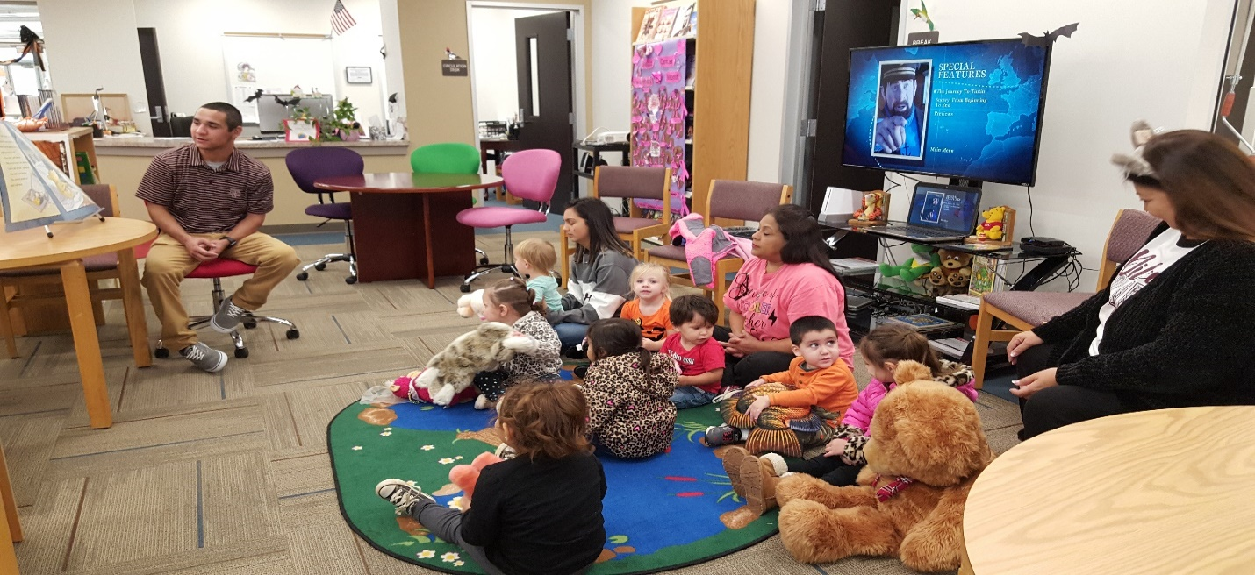
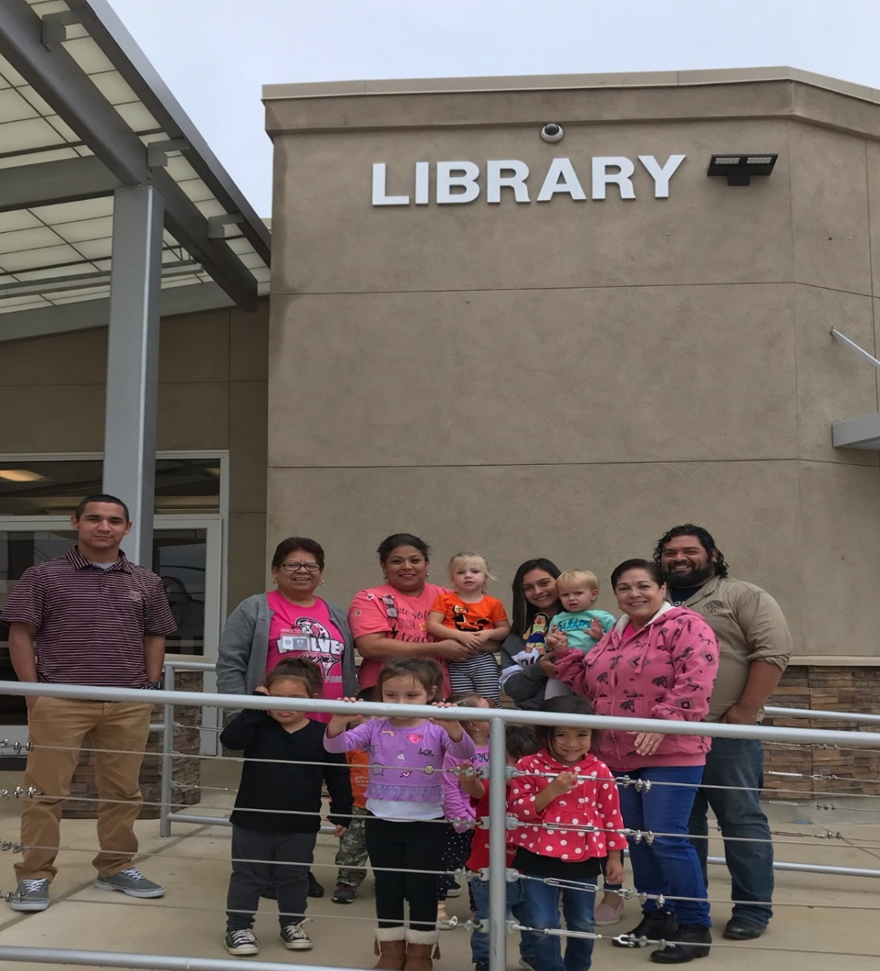
This picture is going to San Marcos ISD Elem School; we are holding Traveling Stella a project send from a child that lives in San Marcos to visit places in Dilley.
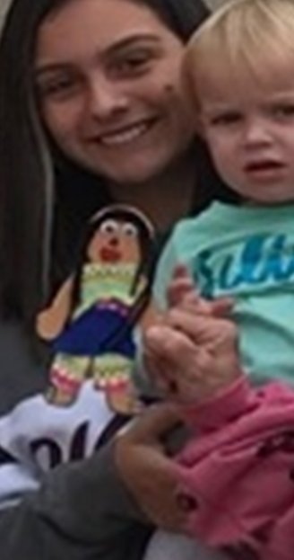

Our Library was one of them!
Halloween Treats For Children

On Oct. 31, 2018, Halloween Day the children from the DISD Day Care and Lil’ Pups visited the library and the City of Dilley for treats. Bags w/candies were passed out to each child and adult.

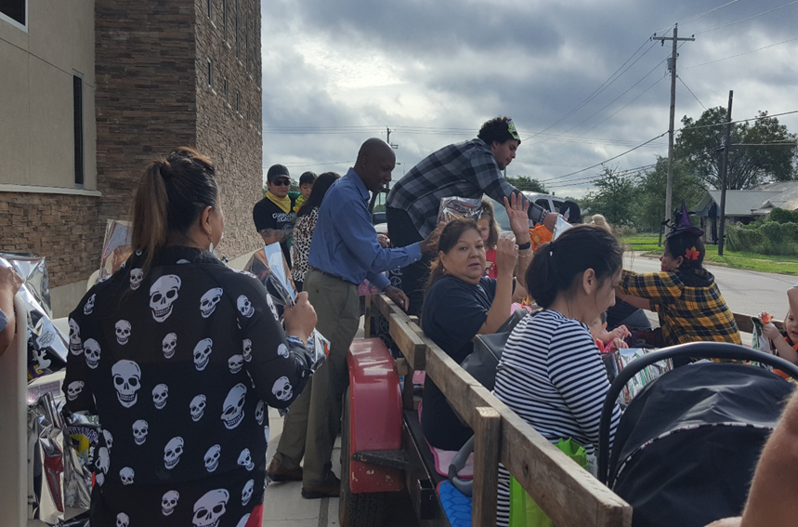

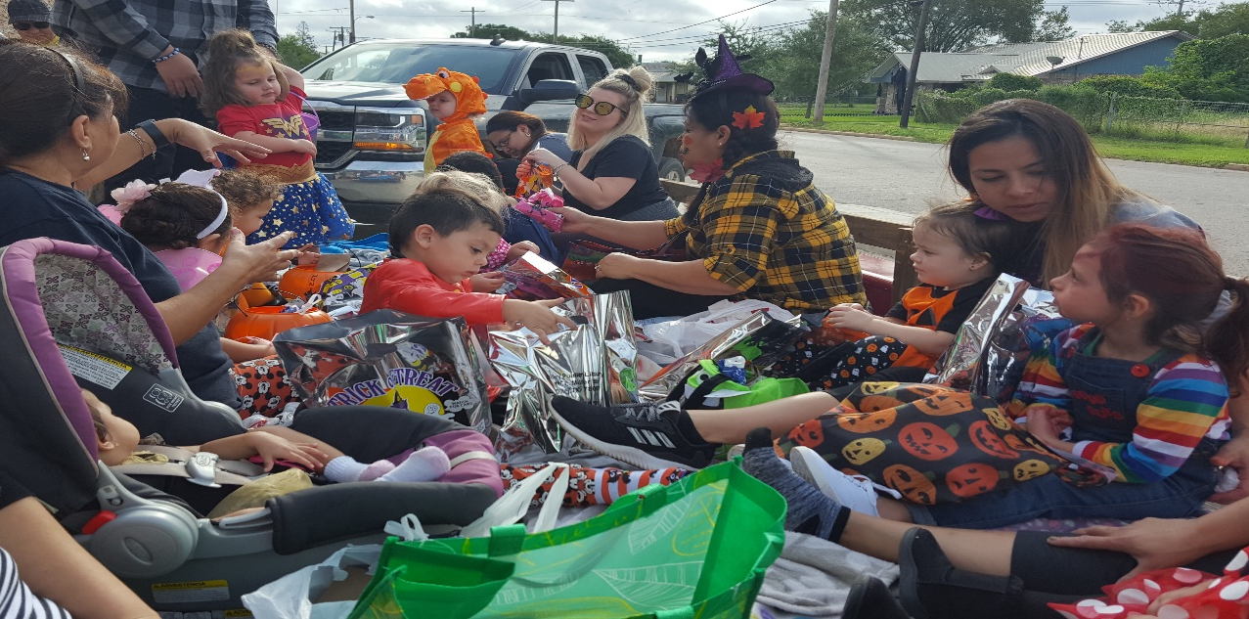

Library High Lights

Nov. 2, 2018 Story Hour with the story “The First Thanksgiving”& Thanksgiving Celebration

Nov. 12th Veteran’s Day/City Hall Closed

Nov. 14th Open Enrollment/Medicare w/ Mrs. Elia Prado

Nov. 16th DISD Early Release for Thanksgiving

Nov. 19th – 23rd DISD Closed

Nov. 22nd & 23rd City Closed for Thanksgiving

